**CHAPTER 1**

**INTRODUCTION**

**1.1 OVERVIEW**

College Alert Management System project is discipline of the planning, organizing and managing the library tasks. The project is specifically designed for the use of students and faculty members. Online Library Information System is basically updating the manual library system into a internet-based application so the users can know the details of their accounts, availability of books and remaining time for borrowing etc. Online Library Information System can be used by any existing or new library to manage it library system like managing books issuing, books returning, insertion and monitoring books. The system allows the Librarian to create the books catalogue, add/delete books and maintain the books catalogue. The system lets the administrator to check which members have booked the books and whether they can borrow any more books or not. The project is specifically designed for the use of librarian and library users. Online Library Information System is basically updating the manual library system into a internet-based application so the users can know the details of their accounts, availability of books and remaining time for borrowing etc.

This project has been developed using PHP (Hypertext Preprocessor) and SQL (Structured Query Language). For formatting we have used HTML (Hypertext Markup Language) and CSS (Cascading Style Sheet).

**1.2 OUTLINE OF PROJECT**

The rest part of this report will provide a detailed description of the Online Library Information System.

CHAPTER 2: This section of the document will provide the proposed work.

CHAPTER 3: This section of the document will provide the result and discussion.

CHAPTER 4: This section of the document will provide the conclusion.

CHAPTER 5: This section of the document will provide the future work.

**CHAPTER 2**

**PROPOSED WORK**

The Online Library System provides online information about the books available in the Library and the user information. The system will provide different types of services based on the type of users [Members/Librarian].

**Administrators**

* Admin should be able to search any book by title, author, category.
* Admin should be able to insert, modify and delete books.
* Admin can issue book and return book.
* Can get the information of any member who has borrowed a book.
* Add new member.
* View Member’s Details
* Activate/Deactivate any member.
* Update his profile.

**Library Members**

* The member should be provided with the updated information about the books catalogue.
* Members have the ability to search books information by category, title, authors.
* Can borrow the book.
* Can return the book.

**2.1 USE CASE OF FUNCTIONALITIES**

**Use case 1: Librarian should login.**

**Primary Actor:** Librarian.

**Scope:** Login.

**Precondition:** None.

**Main Scenario:**

* Both the librarian and library members should be logged in to access the library system.
* Security and Privacy should be maintained. The user’s password must never be exposed to compromise.

**Exception Scenario:**

* If the librarian and library members enter the incorrect e-mail and password then prompt invalid id or password.

**Use case 2: Searching of books by the librarian.**

**Primary Actor:** Librarian.

**Scope:** Book Search.

**Precondition:** Librarian should login.

**Scenario:**

* Librarian should search any book by its title, author and category.
* If the search results are in the list of books, the system should allow the user to choose any one of them to see the details.

**Use case 3: Searching of books by the library members.**

**Primary Actor:** Library Members.

**Scope:** Book Search.

**Precondition:** None.

**Scenario:**

* Library members should search any book by its title, author and category.
* If the search results are in the list of books, the system should allow the user to choose any one of them to see the details.

**Use case 4: Librarian adds the library members.**

**Primary Actor:** Librarian/Library Members.

**Scope:** Sign Up.

**Precondition:** None.

**Main Scenario:**

* New library member added by the librarian.

**Use case 5: Modification of the books by the Librarian.**

**Primary Actor:** Librarian.

**Scope:** Insert Book/ Delete Book/Modify Book.

**Precondition:** Librarian should login.

**Scenario:**

* This is done to add a new book, delete the existing books or modify the details of the existing book in the library’s book collection.

**Use case 6: Activate and Deactivate library members by the librarian.**

**Primary Actor:** Librarian.

**Scope:** Activate and Deactivate Member.

Precondition: Librarian should login.

**Scenario:**

* Librarian should be able to activate and deactivate an existing member due to specific rules.

**Use case 7: Issuing books or taking the issued books back in the library by the librarian.**

**Primary Actor:** Librarian/Library Members.

**Scope:** Issue **/**Return Book.

**Precondition:** Librarian should login.

**Scenario:**

* Librarian should issue the books as per library member requirements.
* Librarian should confirm the return of books borrowed by the library member.

**Use case 8: Librarian should view member's detail.**

**Primary Actor:** Librarian.

**Scope:** View Details.

**Precondition:** Librarian should be login.

**Scenario:**

* The librarian should be able to see the details of the library members.

**Use case 9: Librarian should logout.**

**Primary Actor:** Librarian.

**Scope:** Logout.

**Precondition:** Librarian should be logged in.

**Scenario:**

* The librarian should be logged out after the completion of their work.

**2.2 ARCHITECTURAL DESIGN**

**2.2.1 DFD**

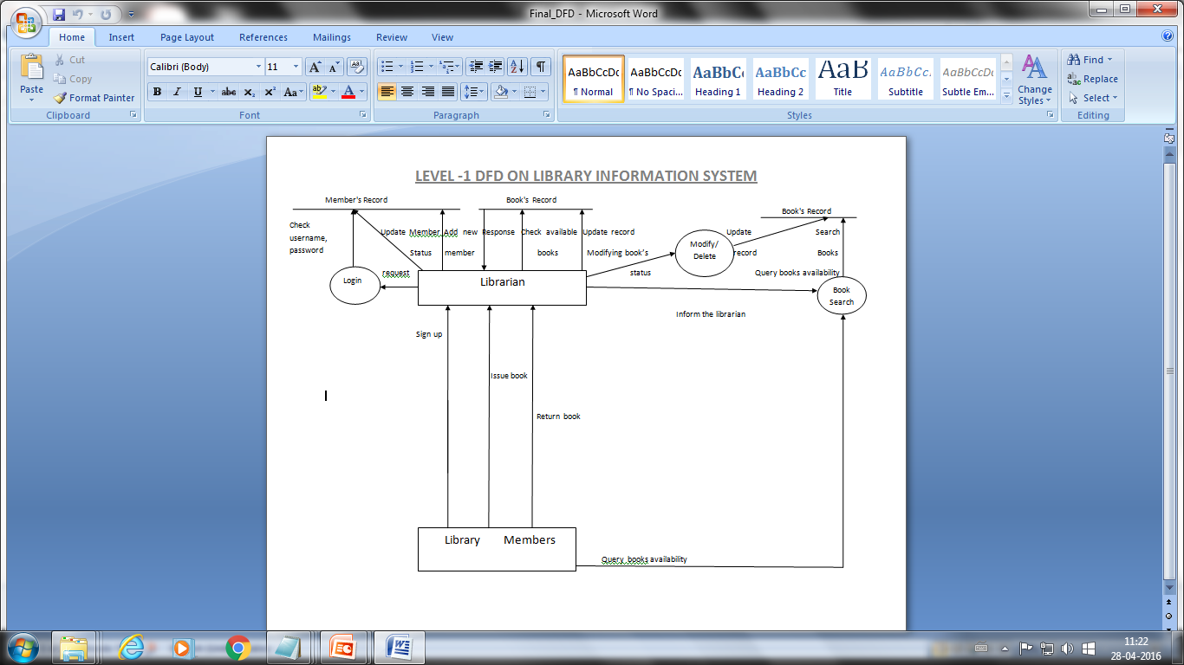

**FIGURE 2.1 DFD LEVEL-1**

**2.2.2 ER-DIAGRAM**

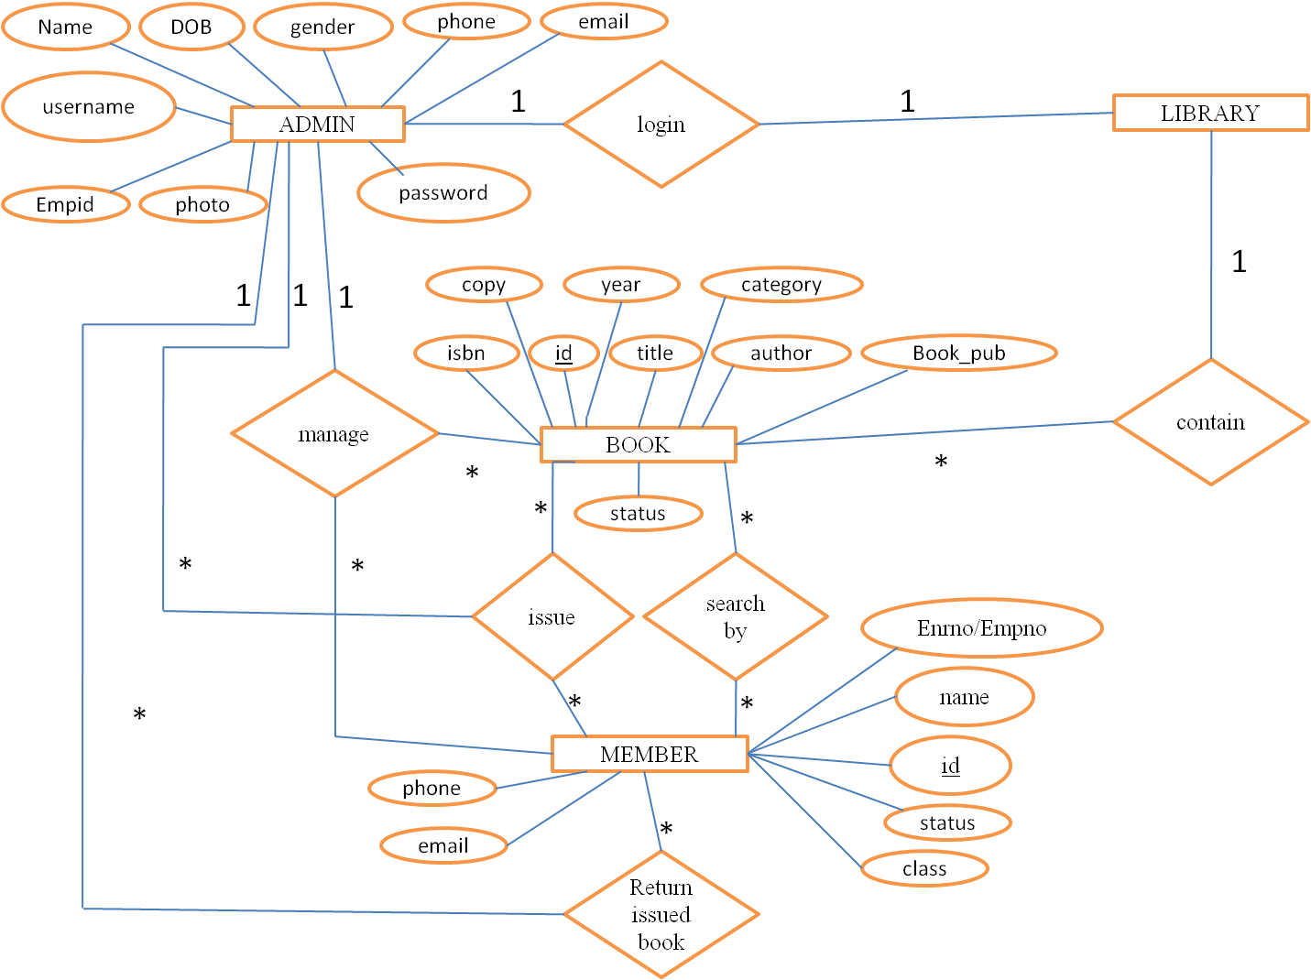

**FIGURE 2.2 ER DIAGRAM**

**CHAPTER 3**

**RESULT**

**AND**

**DISCUSSION**

**3.1 SCREENSHOTS**

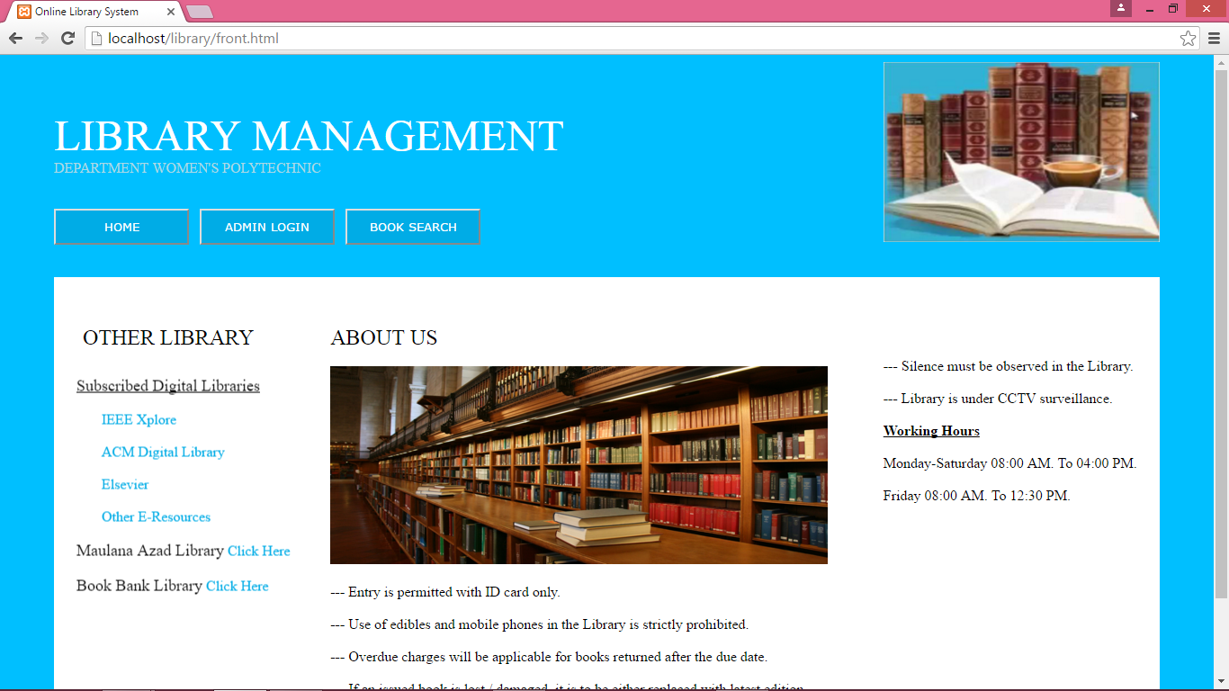

**FIGURE 3.1 HOME PAGE**

Figure 3.1 shows the Home Page of our website. There are three button :

* Home
* Admin Login
* Book Search

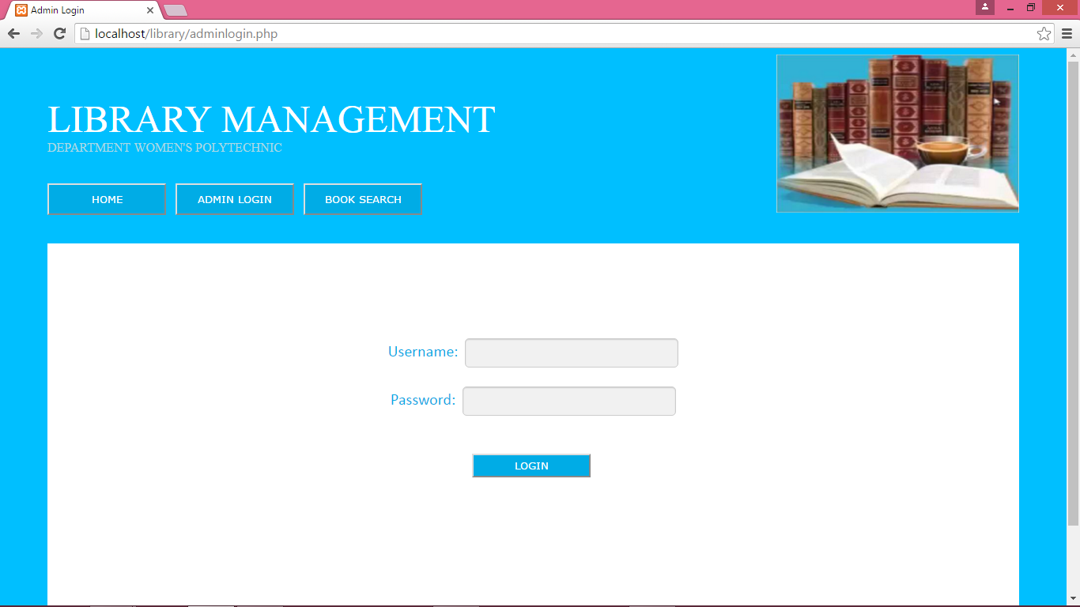

**FIGURE 3.2 ADMIN LOGIN**

Figure 3.2 shows the admin login page where admin will enter his/her username and password and then click on login button; if username or password is match then he/she will be logged in and if username or password is not match then an error message will be displayed on the screen.

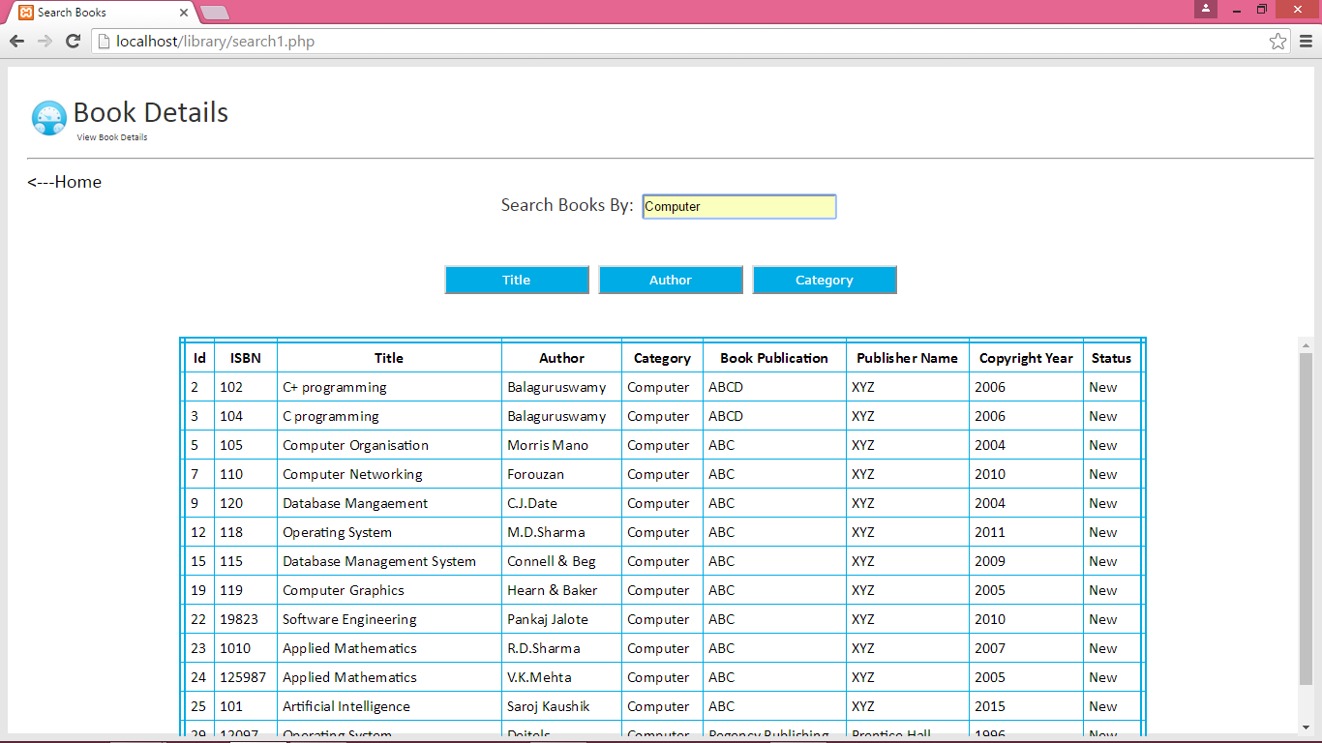

**FIGURE 3.3 BOOK SEARCH**

Figure 3.3 shows the page for searching a book by the library members. Members will search the book by title, author or category and then click on respective buttons and the records of the books will display.

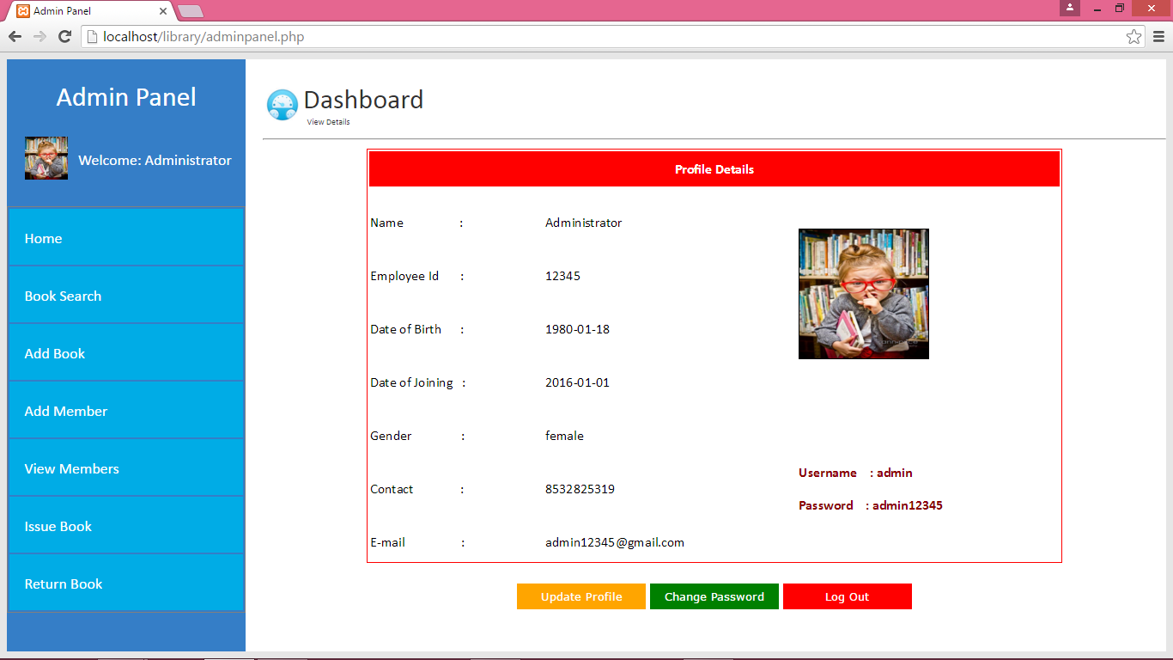

**FIGURE 3.4 ADMIN DASHBOARD**

Figure 3.4 shows the admin panel after his/her successful login.

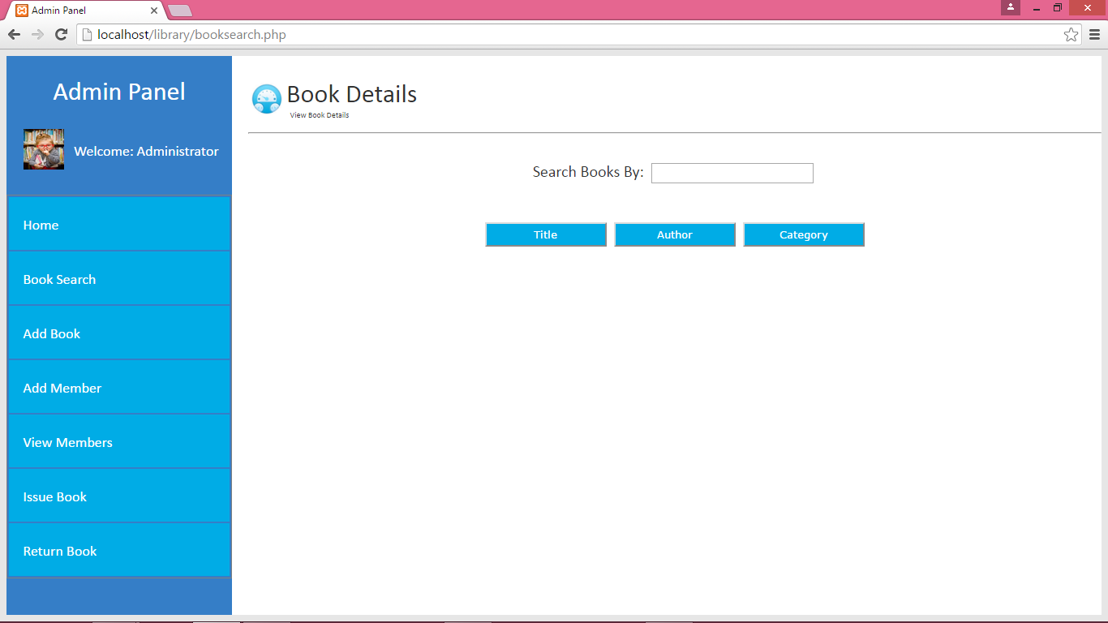

**FIGURE 3.5 BOOK SEARCH**

Figure 3.5 shows the book search screen for admin where he/she can search any book by title, author and category. By clicking any of the one button the result would be displayed as shown in figure 3.6.

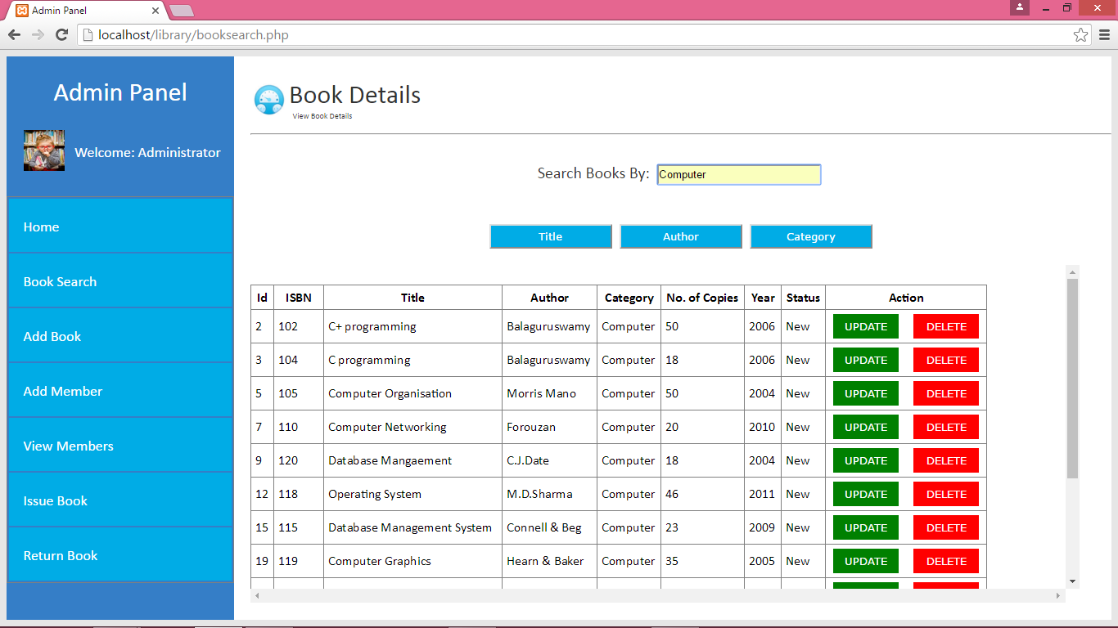

**FIGURE 3.6 BOOK SEARCH**

Figure 3.6 shows the result of the after searching the book. The book details consist an Action column where two link are given for update and delete the book.

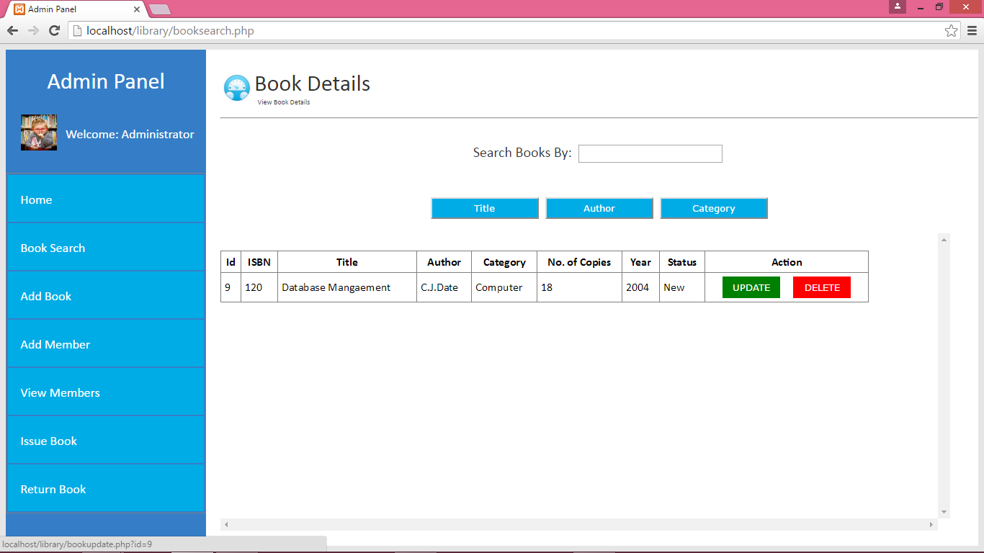

**FIGURE 3.7 BOOK UPDATE**

Figure 3.7 shows the update and delete button. On clicking the update button , a prefilled form of the selected book will be displayed which is shown in Figure 3.8.

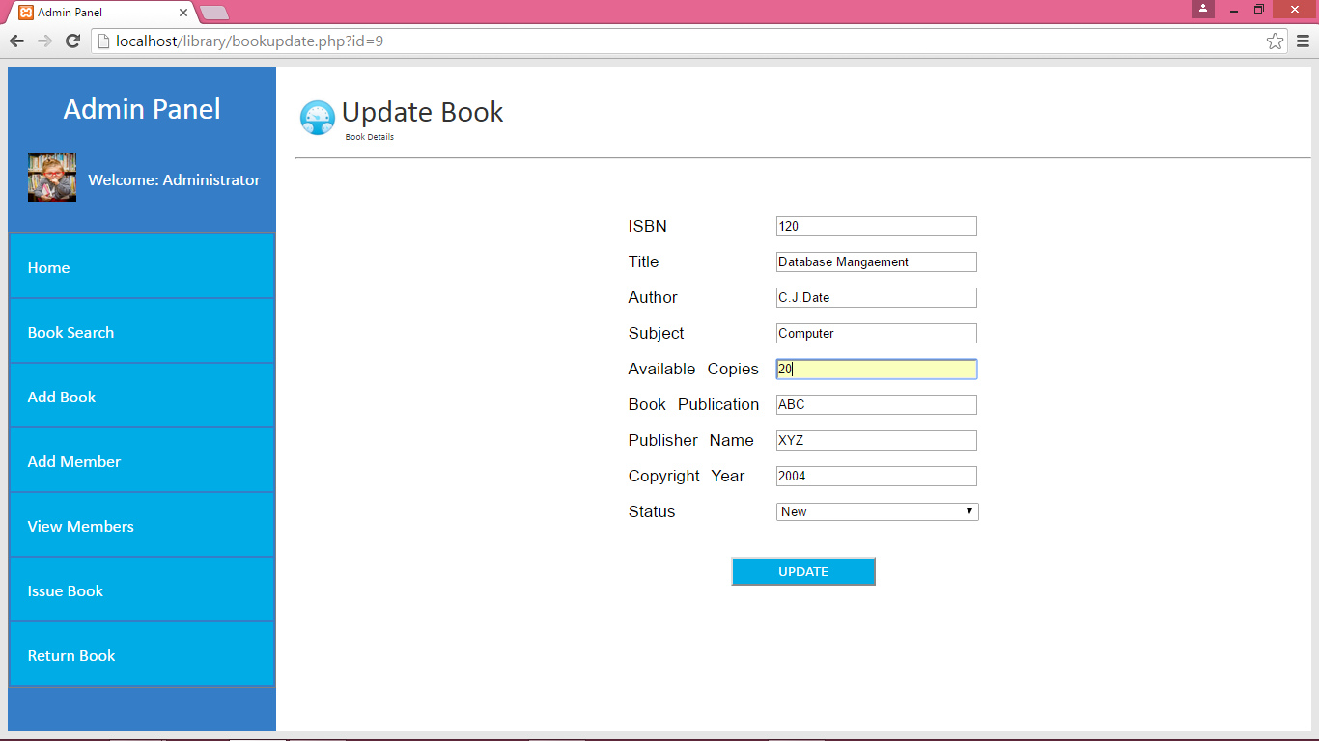

**FIGURE 3.8 BOOK UPDATE FORM**

Figure 3.8 shows an updation form of the selected book that is prefilled with all its require field. Admin can change any field record and click on update button and then "update record" message will be displayed as shown in figure 3.9 and book record updated.

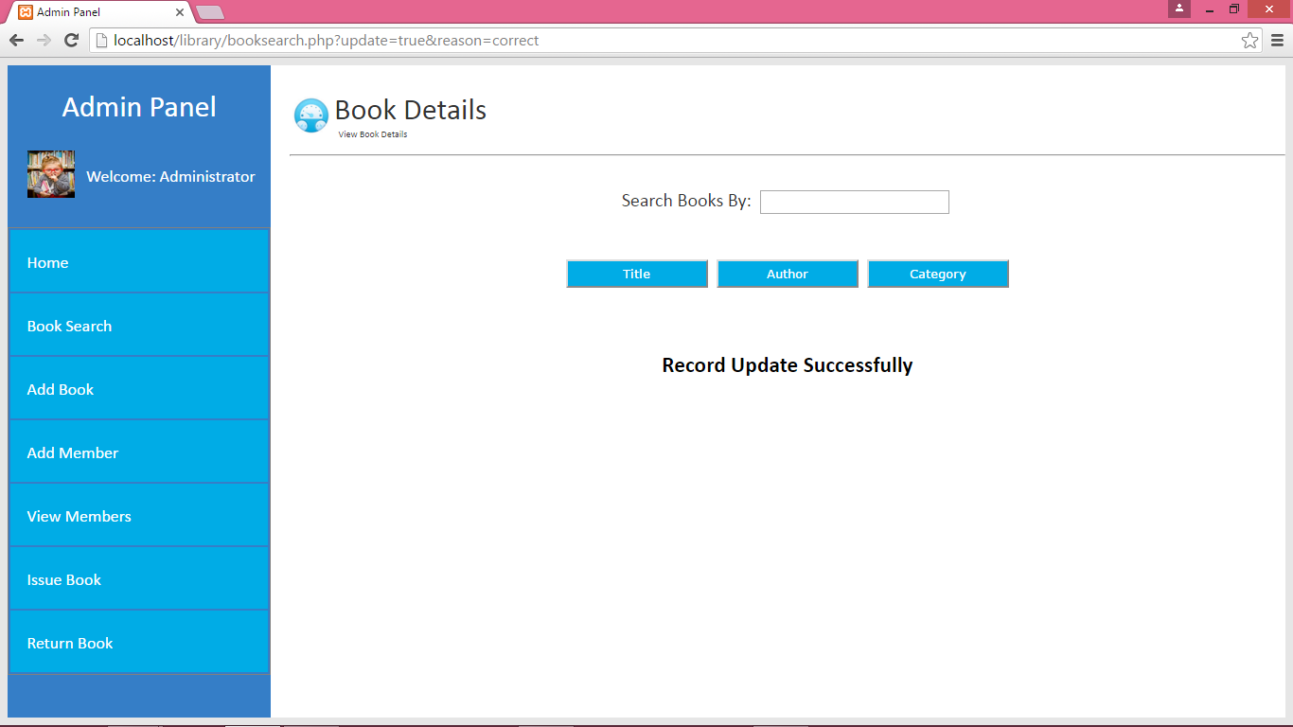

**FIGURE 3.9 AFTER BOOK RECORD UPDATED**

Figure 3.9 shows the message displayed after book's record got updated.

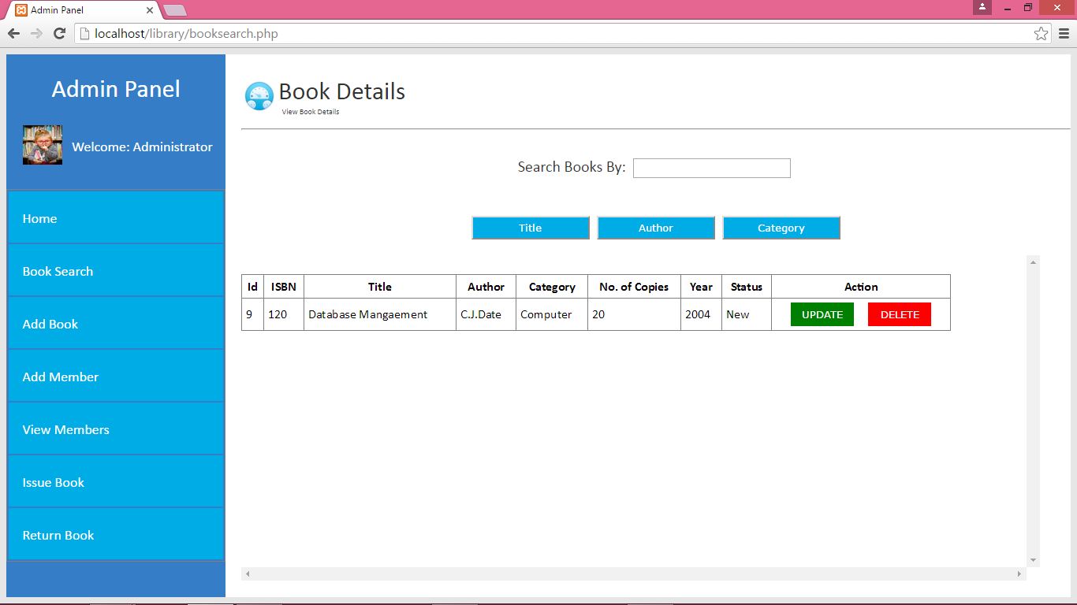

**FIGURE 3.10 DELETE BOOK**

Figure 3,10 shows the button for deleting selected book.

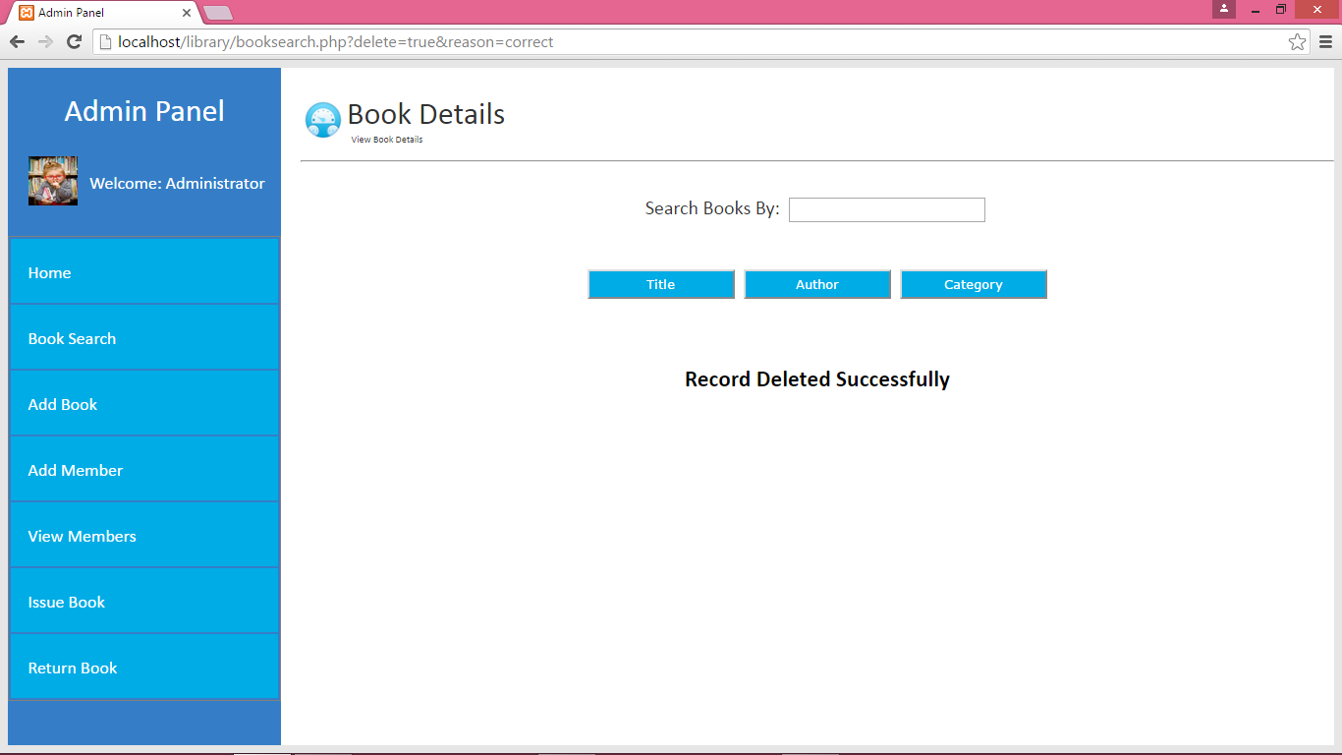

**FIGURE 3.11 AFTER BOOK RECORD DELETED**

Figure 3.11 display the message after deleting the selected book.

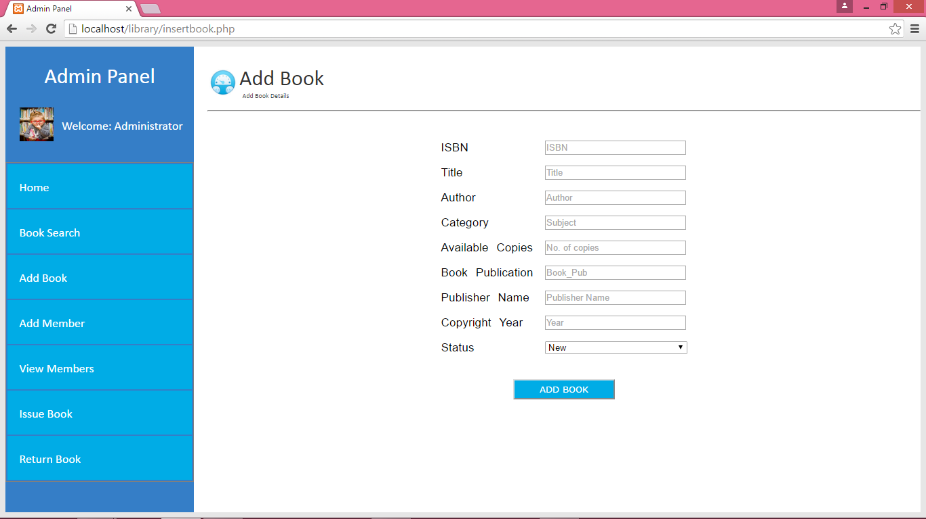

**FIGURE 3.12 ADD NEW BOOK**

Figure 3.12 shows the form for adding a new book record.

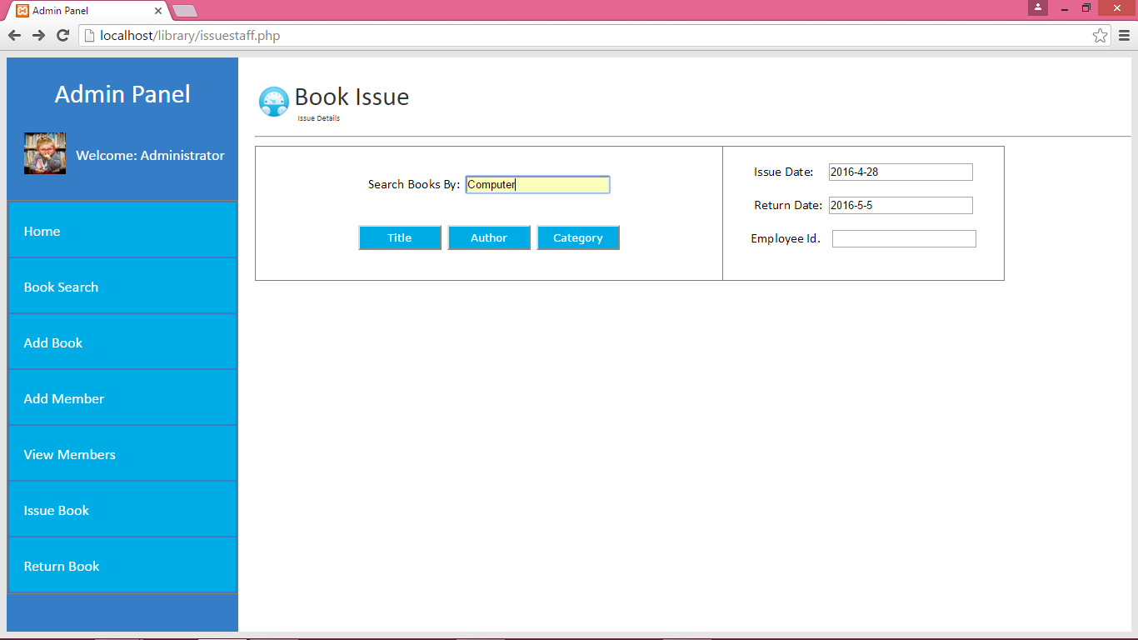

**FIGURE 3.13 ISSUE BOOK**

Figure 3.13 shows the screen for issuing a book.

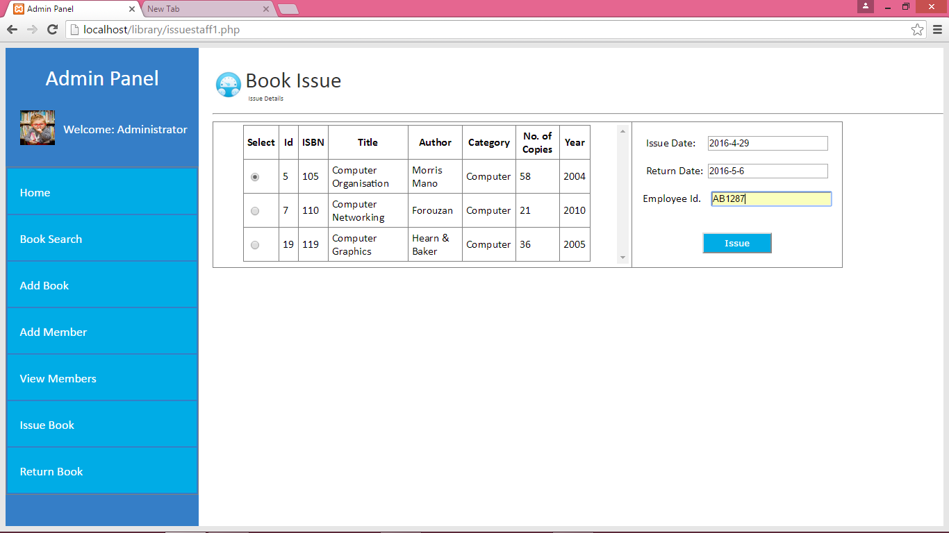

**FIGURE 3.14 ISSUE BOOK**

Figure 3.14 shows the screen for issuing a book after book has been searched.

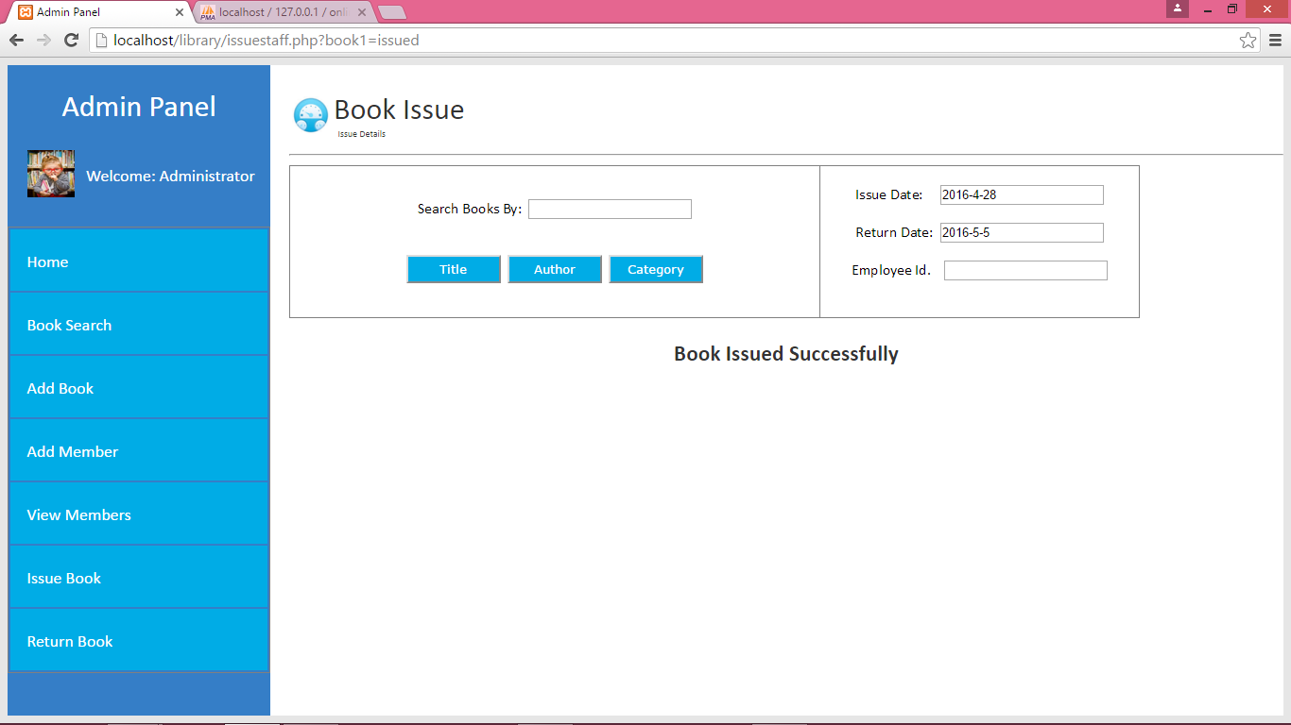

**FIGURE 3.15 AFTER ISSUING A BOOK**

Figure 3.15 shows the message after book is issued.

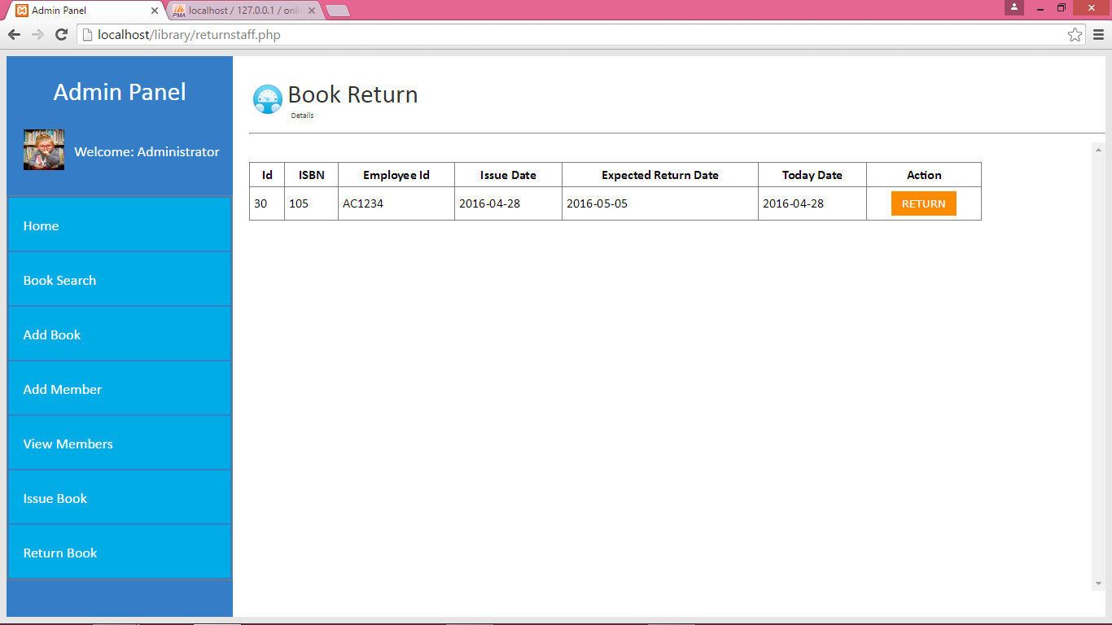

**FIGURE 3.16 RETURN BOOK**

Figure 3.16 shows the list of issued books from where admin can return the book by clicking on the return button.

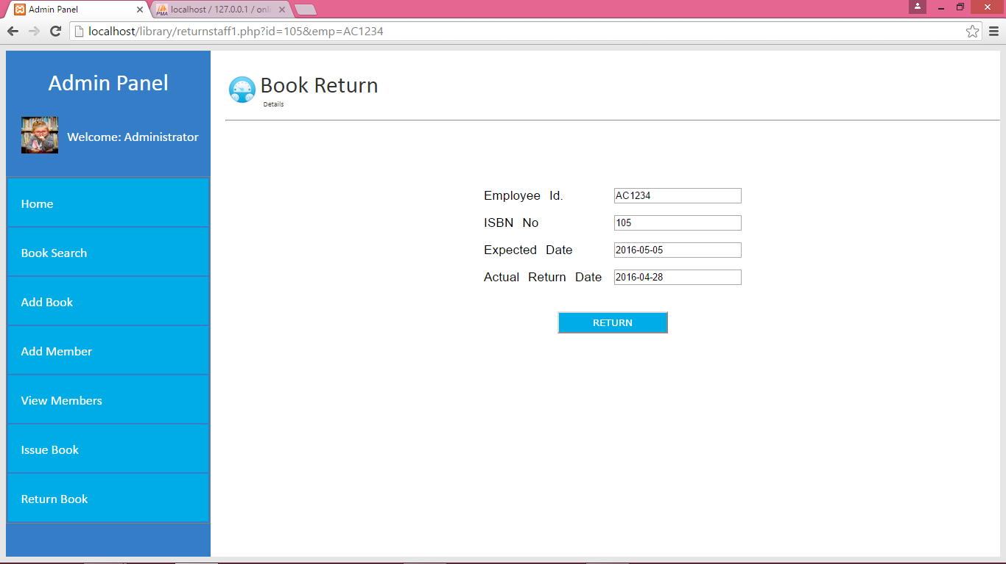

**FIGURE 3.17 BOOK RETURN FORM**

Figure 3.17 shows a form that will be displayed after clicking the return button on screen shown in figure 3.16.

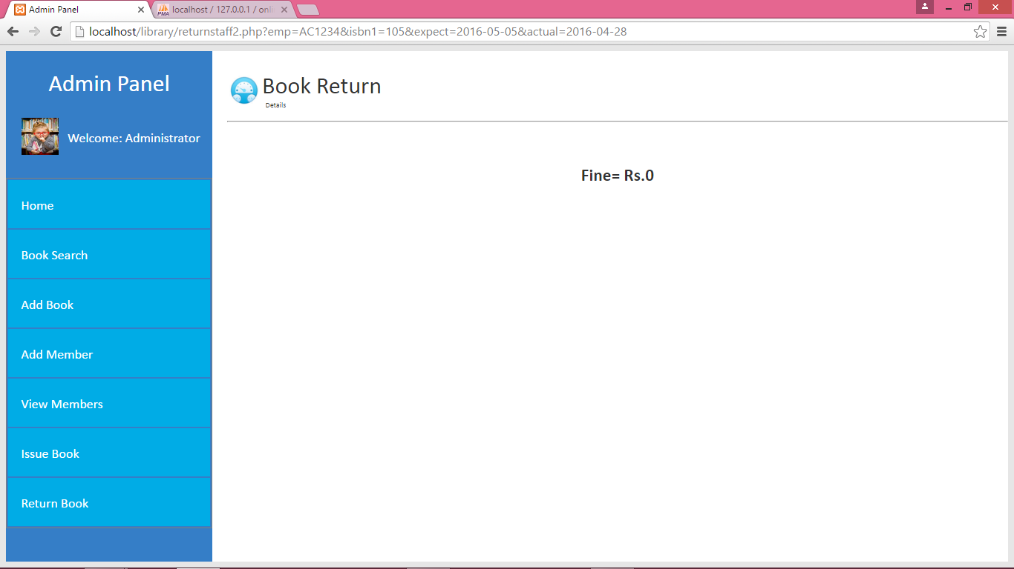

**FIGURE 3.18 CALCULATE FINE**

Figure 3.18 shows the fine that is calculated clicking the return button on screen shown in figure 3.17.

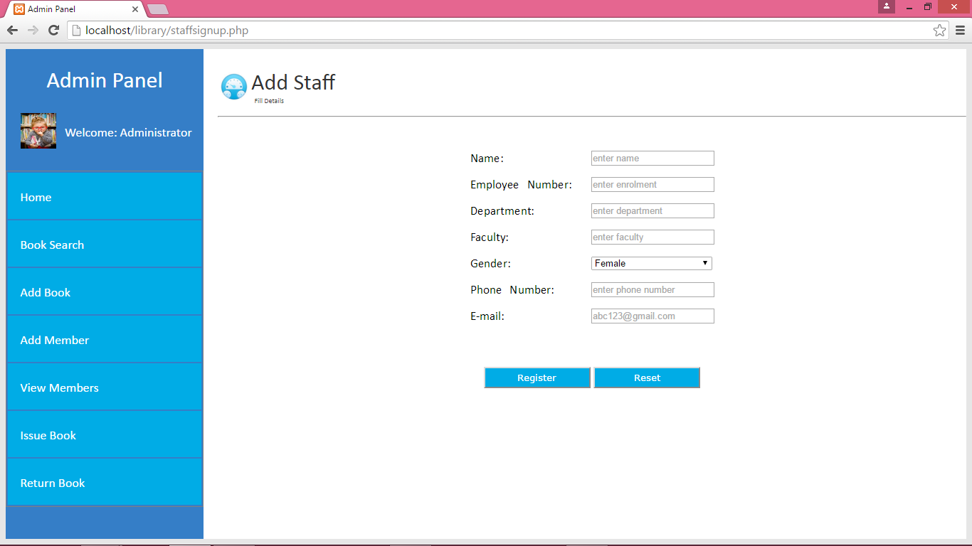

**FIGURE 3.19 ADD MEMBER**

Figure 3.19 shows the form for adding a new member (i.e., staff).

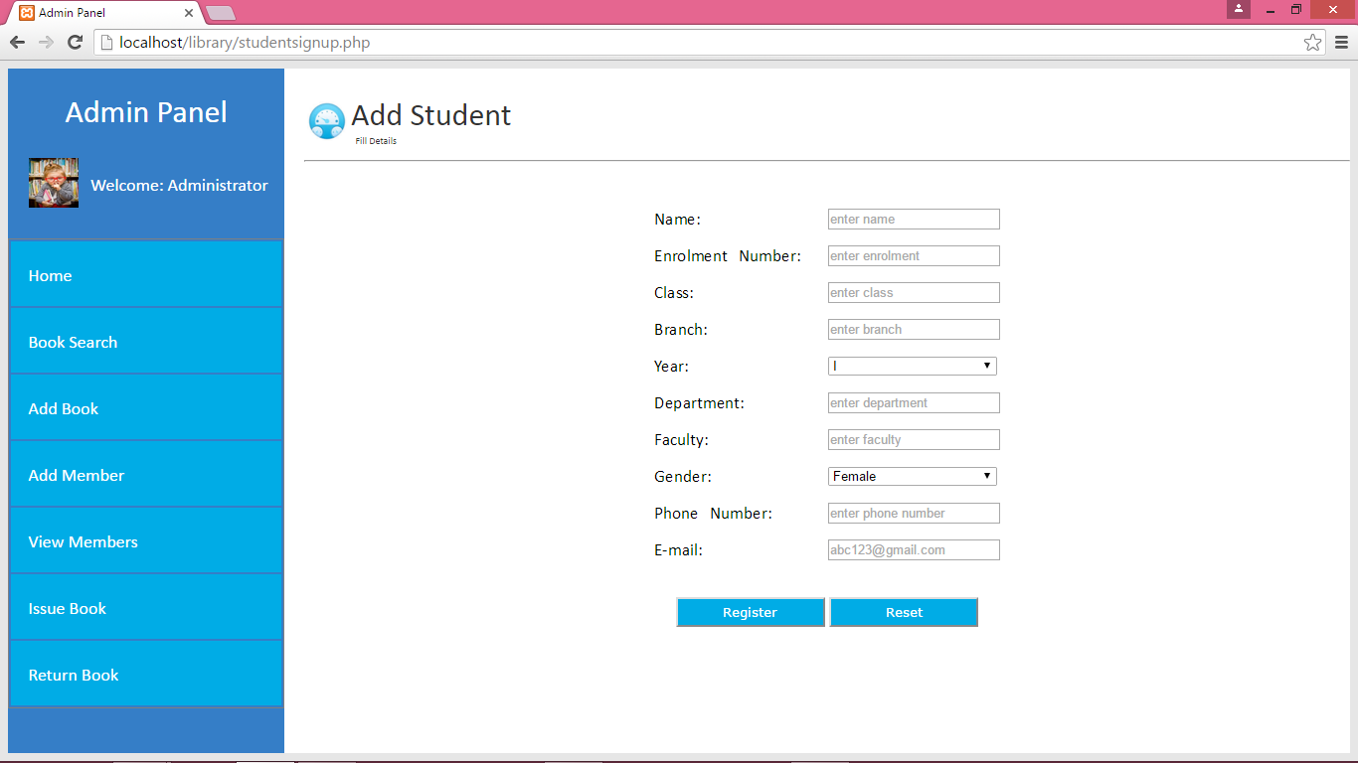

**FIGURE 3.20 ADD MEMBER**

Figure 3.19 shows the form for adding a new member (i.e., student)

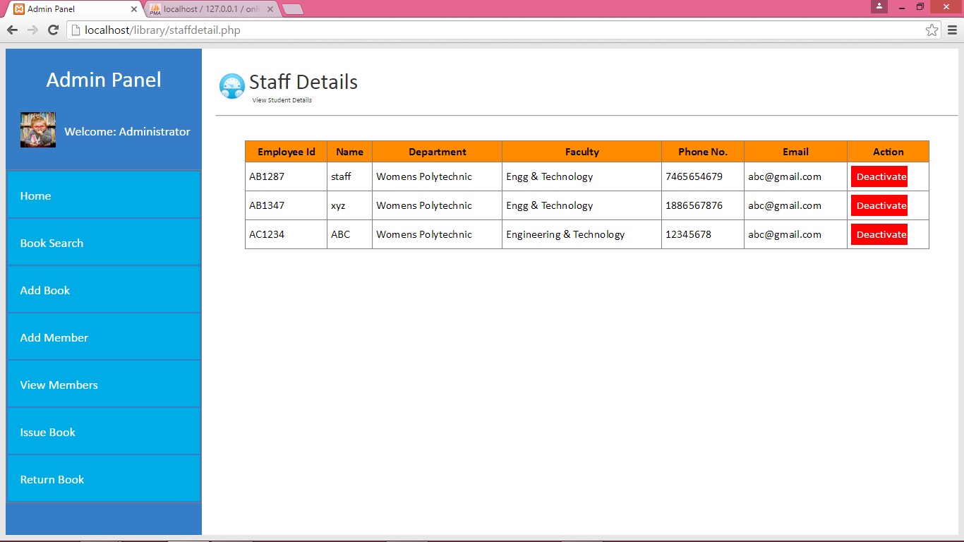

**FIGURE 3.21 DISPLAY MEMBER’S DETAILS**

Figure 3.21 shows the details of members (i.e., staff).

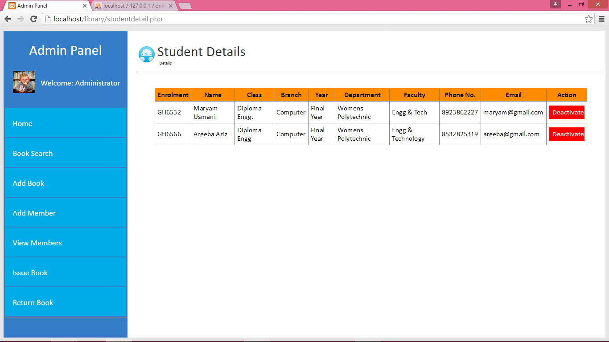

**FIGURE 3.22 DISPLAY MEMBER’S DETAILS**

Figure 3.22 shows the details of members (i.e., student).

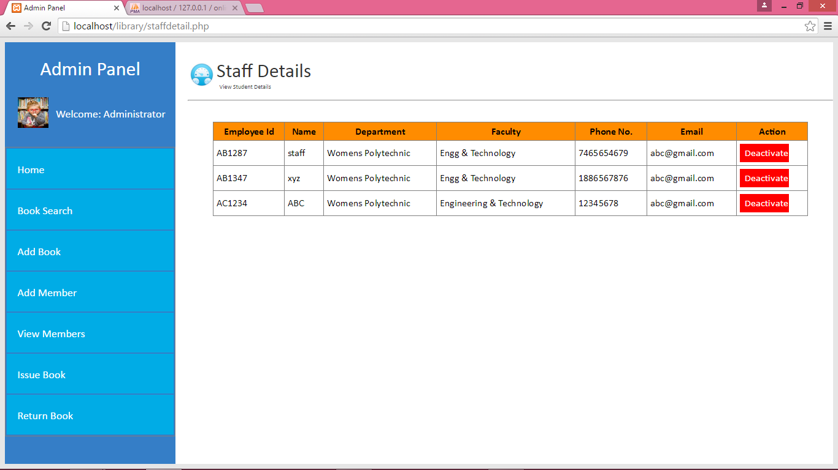

**FIGURE 3.23 ACTIVATE/DEACTIVATE MEMBER**

Figure 3.23 shows the Activate/Deactivate button in the Action column of displayed records from where admin can activate/deactivate the staff members. Same action can be performed for the students also.



**FIGURE 3.24 ADMIN DASHBOARD**

Figure 3.24 shows the dashboard of admin from where he/she update his/her profile, change password and can also logout.

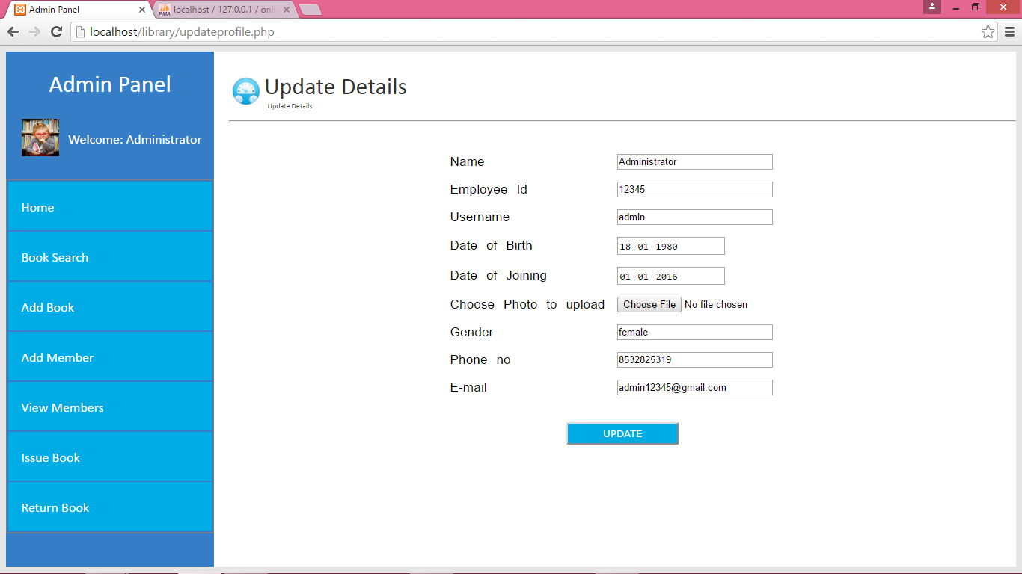

**FIGURE 3.25 UPDATE PROFILE FORM**

Figure 3.25 shows form for updating the admin's profile details.

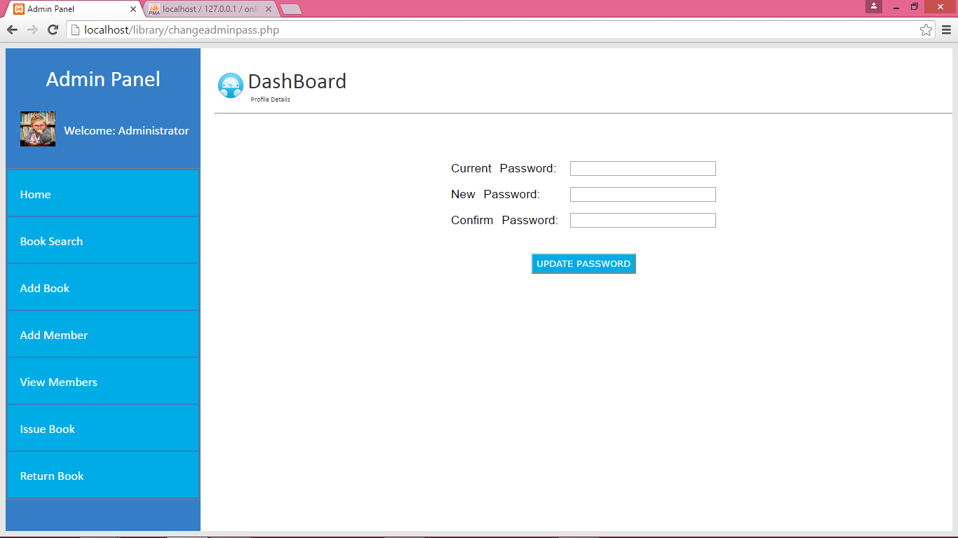

**FIGURE 3.26 CHANGE ADMIN PASSWORD**

Figure 3.26 shows form for changing the admin's current password.

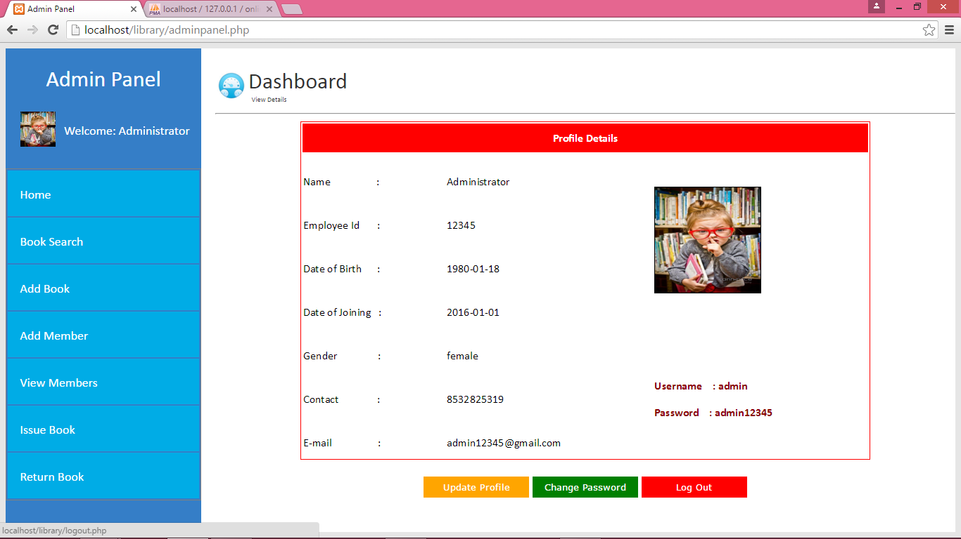

**FIGURE 3.27 ADMIN DASHBOARD (LOGOUT)**

Figure 3.27 shows the logout button. By clicking on it admin will be logged out from the system and came back to admin login page shown in figure 3.2 with a message successful logged out.

**CHAPTER 4**

**CONCLUSION**

It keeps the track of book issued, returned and added to the library .It helps to provide information about the books to the admin as well as the library members.

It is capable to provide easy and effective storage of information related to books and library members.

The Books and Students are given a particular unique id no.  So that they can be accessed correctly and without errors.

Our main aim of the project is to get the correct information about a particular student and books available in the library.

ONLINE LIBRARY INFORMATION SYSTEM is a replacement for the ordinary library systems which depend on paper work for recording books and users information.

To design a user friendly graphical user interface which suit the user.

**CHAPTER 5**

**FUTURE WORK**

Library Management Project is in itself a complete system, though it has a few limitations but it has lot of future scope and features that could be added to make it more widely acceptable.

Further facilities could be added in the library management system like:

* Digital books could be added by the admin for the users.
* Users can share a digital book by adding it to the library if it is not available.
* One limitation is that our software is limited to small and medium scaled libraries. Also apart from Books, Magazine and Newspaper no new category can be added in the system (or in turn be issued) like CDs etc.
* One of the major future scope is making our system online. Connecting libraries to a common data centre will provide globalization to the libraries, and then the user will be able to search books all over the city and nearby areas.
* Reviews, rating, comparing of books and libraries can also be incorporated. This would help the user to browse through popular books and make his selection based on the books rating.

**REFERENCES**

1. http://www.w3schools.com/html/html_intro.asp [Last accessed on 5th May]
2. http://www.w3schools.com/css/css_background.asp [Last accessed on 5th May]
3. http://www.w3schools.com/js/js_datatypes.asp [Last accessed on 5th May]
4. http://www.w3schools.com/sql/sql_insert.asp [Last accessed on 5th May]
5. http://www.w3schools.com/sql/sql_update.asp [Last accessed on 5th May]
6. http://www.w3schools.com/php/php_forms.asp [Last accessed on 5th May]
7. http://www.tutorialspoint.com/php/ [Last accessed on 5th May]
8. http://www.tutorialspoint.com/sql/ [Last accessed on 5th May]
9. http://www.tutorialspoint.com/javascript/ [Last accessed on 5th May]